COBB COUNTY DAYLILY SOCIETY NEWSLETTER
by Diana r. Waldrop

June 25, 2016 www.cobbdaylily.com

What an exciting Summer we have had. In April, Gene led us again in our Daylily Sale at the Jonquil Festival. Katielou brought some daylilies from her garden that were leftover Kirkland plants and Diana and Bill brought many of the Guest Plants that they had grown over the past year that were donated to the National Convention in 2015. Rita and Katielou also worked very hard selling Daylilies for two days at the Master Gardeners Sale on Calloway Road. Both the Jonquil Festival sale and the Master Gardeners sale were very successful.
Then on May 13, 30 members of the CCDS left for Orlando, Florida for a great tour of Florida Gardens, planned by Bill Waldrop.
Our next big event was the Daylily Show and Plant Sale on June 11th. Both our Show and our sale were very successful and we received great publicity from the Marietta Daily Journal.
We also had very sad news with the deaths of Tracey Axleberd and Jane Norlander. Also, Suzanne Franklin had been taking care of her mother for many months and on June 12th, her mom passed away. We send our condolences to these families.
August 2 Board Meeting at Overstreet’s Home, 7:00 p.m.
August 7 General Meeting at 2:00 p.m. Pizza Party & Popularity Poll
August 30 Board Meeting at McKenney’s Home, 7:00 p.m.
September 11 General Meeting - 2:00 p.m. - Election of Officers & Nicole DeVito, Guest Speaker
September 24 Annual Picnic at the Waldrop’s Garden, 4:00 p.m.
October 8 Regional Meeting in Macon, Bill Waldrop Speaker
November 1 Board Meeting at Waldrop’s House 7:00 p.m.
November 13 General Meeting, 2:00 p.m. - Bill Waldrop Speaker
December 4 Christmas Party – 5:00 p.m. to 7:00 p.m. at Hardage Farm Clubhouse

Jonquil Festival in Smyrna, Georgia

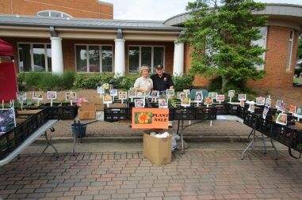
On Saturday and Sunday, April 23-24, 2016, many of our Club members participated in selling our daylilies at the Smyrna Jonquil Festival. The weather was great and we had lots of customers and with Gene’s leadership and many members helping to set up, take down and sell, we sold over $900.00 worth of daylilies. We also gave away CCDS Brochures and perhaps we will benefit from some new members. (Photo is Diana and Gene) Katielou made photos of the daylilies and Diana put the photos on a wooden marker making it easy for customers to see the daylilies. Thanks to Bill Waldrop for offering Smyrna Sunset and Marietta Vineyard for sale for $20.00 each. These daylilies will be 2017 Introductions. Thank you Bill! We also want to thank Gene and all the members who participated in the preparation and sale at the Jonquil Festival. Bill still has both daylilies available. If you would like to purchase either daylily for $20.00, let Diana know.

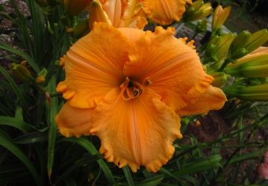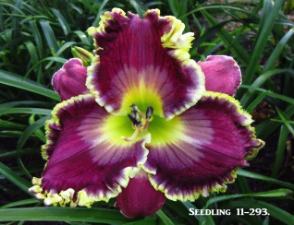
Marietta Vineyard - 2017
Smyrna Sunset - 2017

More Daylily Sales: Rita Buehner and Katielou Greene also sold daylilies at the Master Gardeners Sale on Calloway Road on April 22 and April 23. Many thanks to both of them for working hard for two days to give people an opportunity to purchase beautiful daylilies.

FLORIDA BUS TRIP

On May 12, 2016, thirty (30) members of the CCDS left from the parking lot of the Marietta FUMC to visit “Mecca” in Orlando to see daylily gardens. We had a great driver named Roger who first took us to Dan Hansen’s Garden. We had supper there the first night. It was an interesting evening! The next day we went to Guy and Karen Pierce’s Garden. It was so well kept and very large with thousands of daylilies. We started purchasing plants at Dan’s and then purchased more plants at the Pierce’s garden. We then went a few blocks down the road to Dan and Jane Trimmer’s garden, bought more plants and went next door to see the Riley’s garden. We then had a fabulous lunch at an Italian Restaurant and by that time we were all pretty tired, so we went back to the Hampton Inn for some rest. At 5:00 p.m. we went back to the Pierce’s Garden for barbecue. It was so good to be served drinks before dinner and the barbecue was fabulous! Guy thanked us for coming, we celebrated his Birthday and he then gave us a 2016 daylily! On Sat. morning we went to Nicole’s Daylily Garden and also received a daylily as a gift. We enjoyed visiting with Nicole and saw many beautiful daylilies in her garden. We then traveled a short distance to Pete Harry’s Garden and again received a very nice daylily as our gift. And of course, some of us couldn’t resist purchasing more daylilies! As you can see from the bus picture, we filled up the bus with plants! It was a great trip because our club members got to know each other better and we all learned a great deal more about daylilies. We enjoyed having Joseph Buehner (our new youth member) with us as well as Glenn’s brother and sister-in-law. We arrived back at the church around 6:30 p.m. with many many daylilies. It was a wonderful trip! Thanks Bill for your great planning.

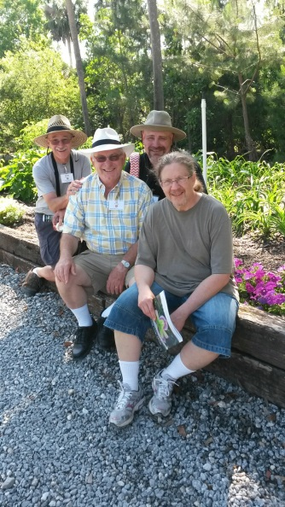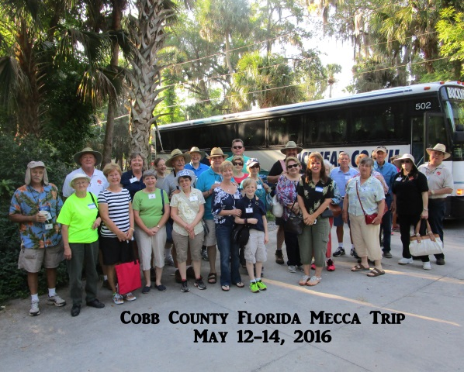
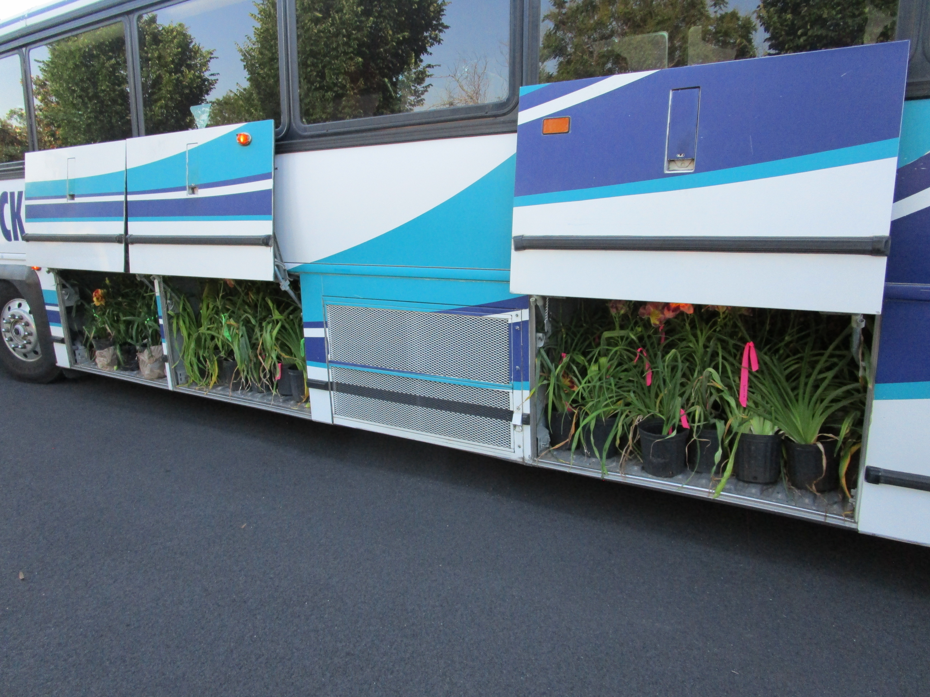

COBB COUNTY DAYLILY SHOW
June 11, 2016
Our 2016 Daylily Show was a huge success. Katielou Greene was our Show Chair along with Bill Waldrop as Co-Chair. Our venue at the Marietta FUMC was great. We had lots of room and lots of help from the Church Staff and our Members! We had 183 entries from 11 people. There were lots of blue and purple ribbons given by the Judges. Our Judges did a great job and we had a wonderful lunch for 43 people prepared by the Church Hostess. Rita has uploaded many photos and made a video of our Show and our Mecca Bus Trip. You can see the work Rita did at Cobbdaylily.com. Thanks so much Rita.
The following members won Best in Section awards: Congratulations!!
Extra Large – Jim Mullins
Large – Katielou Greene
Small – Jim Mullins
Miniature – Jim Mullins
Double, Polymerous and Multiform – Jim Mullins
Spider – Jim Mullins
Unusual form – Jim Mullins
Youth – Tucker Gaby (from Chattanooga)
Popularity Poll – no winner
Seedling – Bill Waldrop
Designers Choice – Camilla Arthur
*Best in Show* – Jim Mullins

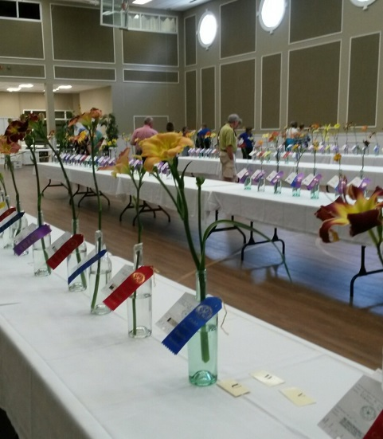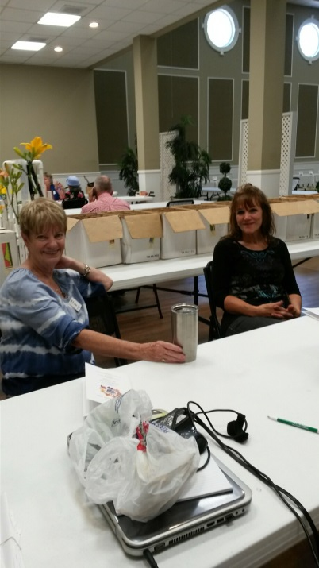
Yvonne & Suzanne relaxing after entering their flowers

Treasurer’s Report from Rita Buehner
Treasurer’s Summary - January 1 through June 18, 2016.

1/1/16 Beginning bank balance $13,994.10
Deposits $11,226.67
Expenditures $10,594.42
6/18/16 Ending bank balance $14,626.35

Breakdown of activity by category:
Dues: $ 474.00
CCDS share of auction (Elliott) $ 472.50
Plant Sales, April $ 1573.69
Plant Sales , Annual Show $ 2527.98
CCDS shirts for sale at cost $ 9.00
Meetings, General Membership ($ 777.01)
Mecca Bus Trip to Florida (31 people) ($ 210.00)
Annual Show & Sale* ($ 2111.02) *
Office Supplies ($ 207.86)
Printing ($ 247.72)
Postage ($ 16.45)
Sales Taxes ($ 246.06)
Other** ($ 608.80) **
*Some reimbursements still outstanding from the annual show. Some expenditures will not recur next year, such as signage, etc.
** ”Other” includes website renewal, AHS memoriam, mileage for speaker, bank checks, AHS brochures, daylily books for sale, corporation annual registration fee, etc.
Submitted by Rita Buehner, CCDS Treasurer 2015/2016

WELCOME NEW MEMBERS
TO THE COBB COUNTY DAYLILY SOCIETY

We are so pleased to welcome the following new members of the Cobb County Daylily Society:
* Ashley Carman, 140 Anita Place, SE., Mableton, Ga. 30126 678-895-5075 Ashley.lizbth@gmail.com
* Jane Exum, 2855 Trickum Road, Woodstock, Ga. 30188 404-281-6641 pulimom@aol.com
* Janice and Stephanie Annee, 363 Hearthstone Trail, Canton, Ga. 30114 770-479-5360 Janannee@windstream.net and Sannee@windstream.net
*New Youth Members: Dylan Buehner, 620 Crossfire Ridge, Marietta, GA. 30064 penzance@bellsouth.net and * Joseph Buehner, 620 Crossfire Ridge, Marietta, GA. 30064 penzance@bellsouth.net
* Pamela Lawrence, 1959 Wellington Lane, Marietta, GA. 30062 678-428-4734 pamelaallison7@gmail.com.
* Sally and David Millard, 1210 Cameron Creek, Marietta, GA. 30062 770-971-2844 shmillard@comcast.net

A Memorial to our Friend, Joan Tracey Axelberd
September 4, 1941 – March 9, 2016

Tracey joined the CCDS, along with her Grandson, Luke Van de Vate, just a few years after we began our club in 2004. She always brought Luke to our meetings and other events. Camilla then asked her to be in charge of the Youth for our Daylily Show and she readily agreed. She always brought food to our meetings and was a very loyal member. Tracey was born in Baltimore, MD and earned her Masters of Education degree at the University of West Georgia. Besides loving daylilies, she enjoyed square dancing. I understand she was pretty good at it too! She was a devoted mother, grandmother and sister. She will be greatly missed.
From Camilla Arthur: We met Tracey Axelberd when her grandson, Luke Van de Vate, joined the Cobb County Daylily Society. Luke was our neighbor and a young student who was interested in gardening at his local elementary school. David Arthur took Luke under his wing and taught him about daylilies. David gave him numerous plants and helped his grow them. When it was time for a daylily show, Luke wanted to participate in the Youth Section. As Chair of the Show, I asked Tracey to become the Youth Chair at the show and help other students. She gladly agreed and for several years mentored the youth in the daylily club. Tracey sent notes to all youth and encouraged them in the gardening of their plants. Our grandchildren received notes from Tracey. We all loved and appreciated Tracey. She was a good friend and will be missed.

ANNUAL DAYLILY
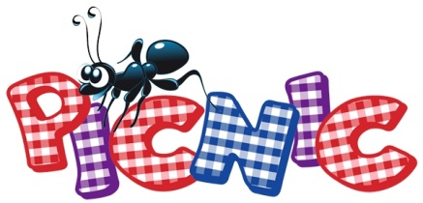

On September 24th at 4:00 p.m. we will have our annual Picnic at Bill and Diana’s Kennesaw Mountain Daylily Gardens. This is also where we use our (MAPS) points to purchase daylilies. We will have a live auction as well as a silent auction and it is your opportunity to purchase or use your points to purchase daylilies! We will also have dinner with the club providing the chicken and everyone bringing a side dish. We will pass around a sign up sheet at our August Meeting. We have about 12 plants from the Pierce Garden purchase and some very nice 2015 Guest plants to Auction. MARK YOUR CALENDAR!!

2016 CCDS Officers

President – Steven Verner 770-262-8911
Vice-President – Glenn McKenney - 770-235-3076
Secretary – Debby Overstreet
Treasurer – Rita Buehner
Parliamentarian – Bill Waldrop
2016 Show Chair – Katielou Greene
2016 Co-Show Chair - Bill Waldrop
Newsletter Editor – Diana R. Waldrop

Our next meeting will be on Sunday, August 7th. We will vote for our favorite daylily and enjoy Pizza. Hope to see you!
2:00 p.m. at Marietta First United Methodist Church, 56 Whitlock Avenue, Marietta, Georgia 30064

